Always Faithful Dobermans
alwaysfaithfuldobermans@gmail.com
695-A Highway 195 Leesburg, GA 31763
(229)869-0827
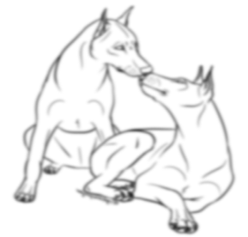
Buyer Questionnaire
The following questions are being asked of you to assist in the most suitable placement for both puppy and family, and to help you in any way I can to provide a more pleasant family setting for everyone. Please answer the following questions as completely as you can, and then return this form when you've finished.
- Name:
- Address:
- Phone :
- Email:
- How did you hear about us?
- Type of dwelling: house apartment
- If renting, please provide a puppy acceptance letter. Note: If renting I must approve first. The rental place must meet certain conditions suitable for a large energetic guard breed.
- Do you have any plans of relocating? If you did, would you ensure a place that your new furry family member can follow?

- Who will be the primary care giver? Will your pup &/or dog have a sitter or go to any doggy care on a regular basis?
- Do you have a fenced yard?
- Do you have a suitable shelter if your dog is sometimes (seldom-short durations) kept outside? (without extreme temperatures or weather conditions) Cannot stay under a shelter where sun exposure can happen or bad weather.
- Will you crate the pup at any time? (Mainly for training &/or time out purposes)
- Do you have any children? If yes, what are their ages?
- Are you or anyone in your family unit physically active and/or enjoy the outdoors a lot?
- What is your favorite outdoor activity (ies) you would like to add your puppy to?

- Are you interested in a male or female puppy? Are you knowledgeable about the slight differences?
- Are you knowledgeable about basic obedience training?
- Will you be attending any training classes?
- Have you ever owned a dog before?
- Have you ever owned a Doberman or been around one? A European Doberman?
- Are you knowledgeable or experienced with ear posting techniques and after surgery maintenance?
- Have you ever returned a pet to the breeder, given it away, or taken it to a shelter? If so, what were the circumstances?

- Are you interested in any competition or performance events? Are you interested in obedience or protection training?
- Are you interested in your dog achieving any titles?
- Are you interested in your pup becoming a therapy dog?
- Why are you interested in a Doberman?

